Alabama Sheriffs Youth Ranches

Wellness Policy

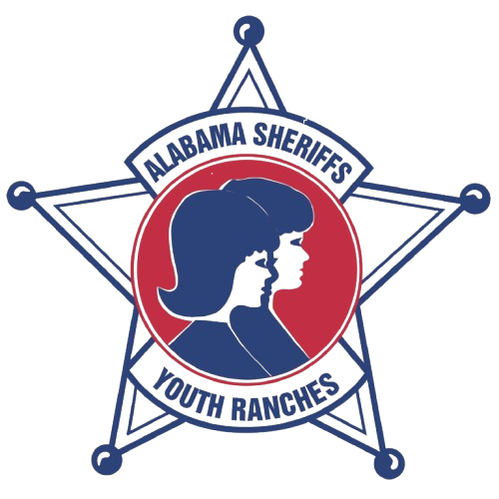

Updated:
2007, 2014, January 2015, November 2016, June 2017, July 2021, March 2024, August 2025
Alabama Sheriffs Youth Ranches, Inc.
Wellness Policy

The policies outlines within this document are intended to create an environment that protects and promotes the health of our Ranchers. This policy applies to all Ranches in our organization. Our commitments to providing nutrition education and regular physical activity, as well as access to nutritious foods for all Ranchers, are described here.

- Nutrition education and promotion

Ranchers will receive consistent nutrition messages throughout the Ranch houses and offices.
- Staff will integrate nutrition education into core curricula;
- Nutrition promotion will include participatory activities such as contests, and experience working in gardens
- Nutrition education will promote fruits, vegetables, whole-grain products, low-fat dairy products, healthy food preparation methods, and accurate portion sizes;
- Ranchers will have opportunities to taste foods that are low in saturated and trans fats, sodium and added sugar;
- Staff members responsible for nutrition education will regularly participate in relevant professional development (e.g. training on the Dietary Guidelines for Americans and how to teach them);
- Staff will only use approved nutrition curriculum in the homes. Curriculum developed by corporate interests is prohibited.
- Nutrition education will be provided to Ranch families via handouts, presentations and workshops;
- Staff is strongly encouraged to model healthful eating habits, and discouraged from eating in front of children/sharing food with children during non-meal times, outside of activities related to the nutrition education curriculum.
Specifically, the nutrition curriculum will encompass:
- Promotion of adequate nutrient intake and healthy eating practices;
- Skill development, such as reading labels to evaluate the nutrient quality of foods, meal planning, analysis of health information;
- Examination of the problems associated with food marketing to children;
- Nutrition themes including, but not limited to USDA’s MY Plate, Dietary Guidelines for Americans, adequate nutrient intake (such as carbohydrates, proteins, fats), body image and food safety.

- Nutrition Standards for All Food and Beverages Served on Ranch Grounds
- USDA Meals:
Ranch meals will include a variety of healthy choices while accommodating special dietary needs and ethnic and cultural food preferences. Ranches will serve at least (3) meals per day including between-meal and nighttime snacks. All Ranches shall participate in the USDA school breakfast, school lunch, and summer food programs.

In addition:
- All reimbursable meals will meet nutrition standards mandated by the USDA, as well as any additional state nutrition standards that go beyond USDA requirements.
- All staff will be provided training on USDA meal plans/reimbursable meals so they can properly advise Ranchers as to the meal components they may/must take, as well as cooking techniques, recipe implementation, sanitation, and food safety;
- All menus will be reviewed by the Nutrition Program Coordinator who utilizes sample USDA menus and USDA software for menu review;
- Ranchers will be provided at least 10 minutes to eat breakfast and 20 minutes to eat lunch at meal times;
- Meals will be served in a clean and pleasant setting and under appropriate supervision. Rules for safe behavior will be consistently enforced;
- Lunch will be scheduled between 11 a.m. and 1 p.m.
- Tutoring, club, or organizational meetings will not be scheduled during meal time, unless Ranchers may eat during such activities;
- Ranchers will have access to hand washing/hand sanitizing before meals and snacks and staff will remind them to make use of them;
- Information on the nutritional content and ingredients of meals will be found on menus and in offices. Staff and Ranchers will be informed that this information is available and information shall be kept up-to-date.

- Competitive Foods and Beverages
The Ranches do not participate in competitive foods and beverages. There is never a charge for any foods or beverages.

- Access to Drinking Water
- Ranchers and staff members will have access to free, safe, fresh drinking water at all times throughout the day. Supervisory staff will facilitate access to water in the kitchens of all houses.
- Water will be promoted as a substitute for sugar-sweetened beverages (SSBs)
- Staff will be encouraged to model drinking water consumption.

- Food used as reward or punishment
Research clearly indicates that the use of food to reward/reinforce desirable behavior and academic performance, etc., has negative, unintended consequences. The use of food as a reward and withholding food as a punishment are strictly prohibited.

- Physical Activity
Staff will be expected to incorporate opportunities for physical activity whenever possible and will be encouraged to serve as role models by being physically active alongside the Ranchers.

- Evaluation and Enforcement
This wellness policy was developed by the Food & Nutrition Program Coordinator in coordination with the Wellness Committee. The Wellness Committee includes each Ranch Director, one or more houseparents and Ranchers from each location, and the Chief Executive Officer. The coordinator will review and revise, if needed, policy content and design and implementation plans throughout the Ranch program. The coordinator will also undertake additional tasks consistent with the wellness policy guidelines issued by the USDA. The coordinator will provide initial and ongoing training to all direct care staff.

The Director of each Ranch will ensure compliance with these guidelines and will report on compliance to the CNP Director. The Ranch Director implements the policy and will collect, summarize and report on evaluation data to the program coordinator.

In accordance with Federal civil rights law and U.S. Department of Agriculture (USDA) civil rights regulations and policies, the USDA, its Agencies, offices, and employees, and institutions participating in or administering USDA programs are prohibited from discriminating based on race, color, national origin, religion, sex, gender identity (including gender expression), sexual orientation, disability, age, marital status, family/parental status, income derived from a public assistance program, political beliefs, or reprisal or retaliation for prior civil rights activity, in any program or activity conducted or funded by USDA (not all bases apply to all programs). Remedies and complaint filing deadlines vary by program or incident.
Persons with disabilities who require alternative means of communication for program information (e.g., Braille, large print, audiotape, American Sign Language, etc.) should contact the responsible Agency or USDA's TARGET Center at (202) 720-2600 (voice and TTY) or contact USDA through the Federal Relay Service at (800) 877-8339. Additionally, program information may be made available in languages other than English.
To file a program discrimination complaint, complete the USDA Program Discrimination Complaint Form, AD-3027, found online at How to File a Program Discrimination Complaint and at any USDA office or write a letter addressed to USDA and provide in the letter all of the information requested in the form. To request a copy of the complaint form, call (866) 632-9992. Submit your completed form or letter to USDA by: (1) mail: U.S. Department of Agriculture, Office of the Assistant Secretary for Civil Rights, 1400 Independence Avenue, SW, Washington, D.C. 20250-9410; (2) fax: (202) 690-7442; or (3) email: program.intake@usda.gov.
USDA is an equal opportunity provider, employer, and lender.

